NURS XXX
SDG goals and definitions:
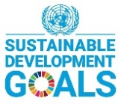 http://sustainabledevelopment.un.org/sdg17
The 2030 Agenda for Sustainable Development, adopted by all United Nations Member States in 2015, provides a shared blueprint for peace and prosperity for people and the planet, now and into the future. At its heart are the 17 Sustainable Development Goals (SDGs), which are an urgent call for action by all countries - developed and developing - in a global partnership. They recognize that ending poverty and other deprivations must go hand-in-hand with strategies that improve health and education, reduce inequality, and spur economic growth – all while tackling climate change and working to preserve our oceans and forests.

SDG Indicators https://ourworldindata.org/sdg-tracker-update

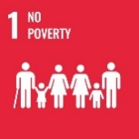End poverty in all its forms everywhere
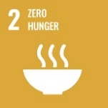End hunger, achieve food security and improved nutrition, and promote sustainable agriculture
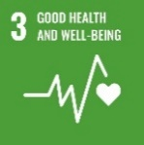Ensure healthy lives and promotes well-being for all at all ages
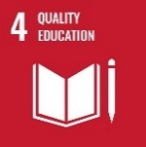Ensure inclusive and equitable quality education and promote lifelong learning opportunities for all
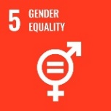Achieve gender equality and empower all women and girls
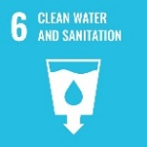Ensure availability and sustainable management of water and sanitation for all
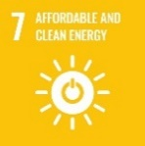Ensure access to affordable, reliable sustainable and modern energy for all
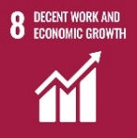Promote sustained, inclusive and sustainable economic growth, full and productive employment and decent work for all
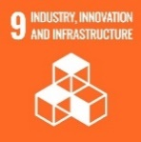Build resilient infrastructure, promote inclusive and sustainable industrialization and foster innovation
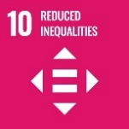Reduce inequality within and among countries
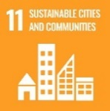Make cities and human settlements inclusive, safe, resilient and sustainable
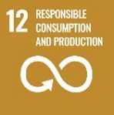 Ensure sustainable consumption and production patterns
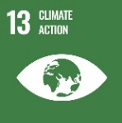 Take urgent action to combat climate change and its impact
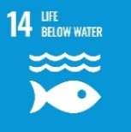 Conserve and sustainability use the oceans, seas and marine resources for sustainable development
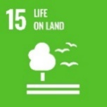 Protect, restore and promote sustainable use of terrestrial ecosystems, sustainably manage forests, combat desertification, and halt biodiversity loss.
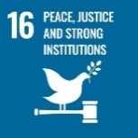 Promote peaceful and inclusive societies for sustainable development, provide access to justice for all and build effective, accountable and inclusive institutions at all levels
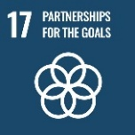 Strengthen the means of implementation and revitalize the global partnership for sustainable development

Content Areas | SDG 1 | SDG  2 | SDG  3 | SDG 4 | SDG 5 | SDG 6 | SDG 7 | SDG  8 | SDG 9 | SDG  10 | SDG  11 | SDG  12 | SDG  13 | SDG  14 | SDG  15 | SDG  16 | SDG  17

Our thoughts to guide decision-making:
1-Basic services
5- Gender—gender identification, gender-based variable, sexual health, health decision (efficacy)
6-drinking water, sanitation, handwashing
8- material footprint
9-Research
10-financial soundness, equal participation, access
11-Cultural Heritage
12- sustainable consumption plans, material footprint, hazardous waste, recycling rates, corporate/national plans
14- disposal, marine life impact
15-anything, biodiversity, land protection
16-Public Safety, violence, conflict related deaths, illegal finance flow, trafficking, human rights, public information access, decision making

Pennsylvania State University, College of Nursing, Sustainability Council / Charter

